# HTML and CSS

## EXERCISE 5: BASIC PHOTO ALBUM

Download the resource file **photoalbum1.zip** from moodle. Extract the files and put them into your dba web root folder. Then view **photoalbum-manual-exercise.html** in a web browser. Only two of the Beatles are displayed, and when the window is wide there is a lot of empty space. The photographs are intended to be displayed in rows of three, so two need adding to the first row.

Examine the HTML code and experiment with narrowing the window. Note that the descriptive text to the right of the images jumps down to below the image when the window is narrow enough, and that before this happens the row of three images becomes a vertical column still with the descriptions on the right. This will make more sense once you have added the other two Beatles to the first row. Once you have done this the results should look like the pictures below:

|  |  |
| --- | --- |
| WIDE (3 pictures per row and descriptions to the right of the picture). | |
| NARROW  (1 picture per row with the description to the right of the picture) | NARROWER  (All in one vertical column) |

Write an explanation of how the w3css classes achieve the changing layout of the photographs and descriptions, and the cards they are on, as the window width changes, in your report.

Notice that when you click on a photograph it opens it in the whole window. This is OK but a little crude. We can improve upon it using a JavaScript based image display utility.

### Lightbox and JQuery

Lightbox is a widely used solution to allowing users to display images bigger than they are when embedded in the web page. It is based upon the JavaScript library JQuery and so to use it we must first add JQuery to the page. The easiest way to include JQuery is to pull in the required JavaScript file from the developers’ own server. To do this, add the following line into the **head** section of the web page:

<script src='http://code.jquery.com/jquery-1.11.3.min.js'></script>

This has no effect on the page, but makes a lot of powerful JavaScript functions available to use in it. You can read about JQuery and see lots of examples at <http://jquery.com>.

Next we need to add the Lightbox code to the page. The lightbox code is stored in the lib folder of the photoalbum1.zip archive you downloaded from moodle. You need to make sure the lib folder is next to your web page, and then add lines to add lightbox to your page. Lightbox has two parts. The first is a CSS file which you need to add the same way the w3css file is included, with a line like this, again in the **head** part of the page:

<link rel='stylesheet' href='lib/lightbox2/css/lightbox.css'>

The second thing you need to do is import the JavaScript that makes lightbox work. This is done similar to how JQuery was added, but for technical reasons it must be added at the very bottom of the page, just before the end body tag </body>. This is the line you need:

<script src='lib/lightbox2/js/lightbox.js'></script>

To tell lightbox to display an image, you need to wrap it in an <a> element to make it clickable, and give that <a> tag a special attribute lightbox recognises. The attribute is “**data-lightbox**” and its value is a name for a group of images you want the user to be able to step through. All the images on the page already have an <a> tag around them. You just need to add the attribute to each of them, something like this:

<a data-lightbox='example-1' href='images/*whatever…*’>

Once you have done that clicking the images brings them up in the lightbox display window, as shown below:

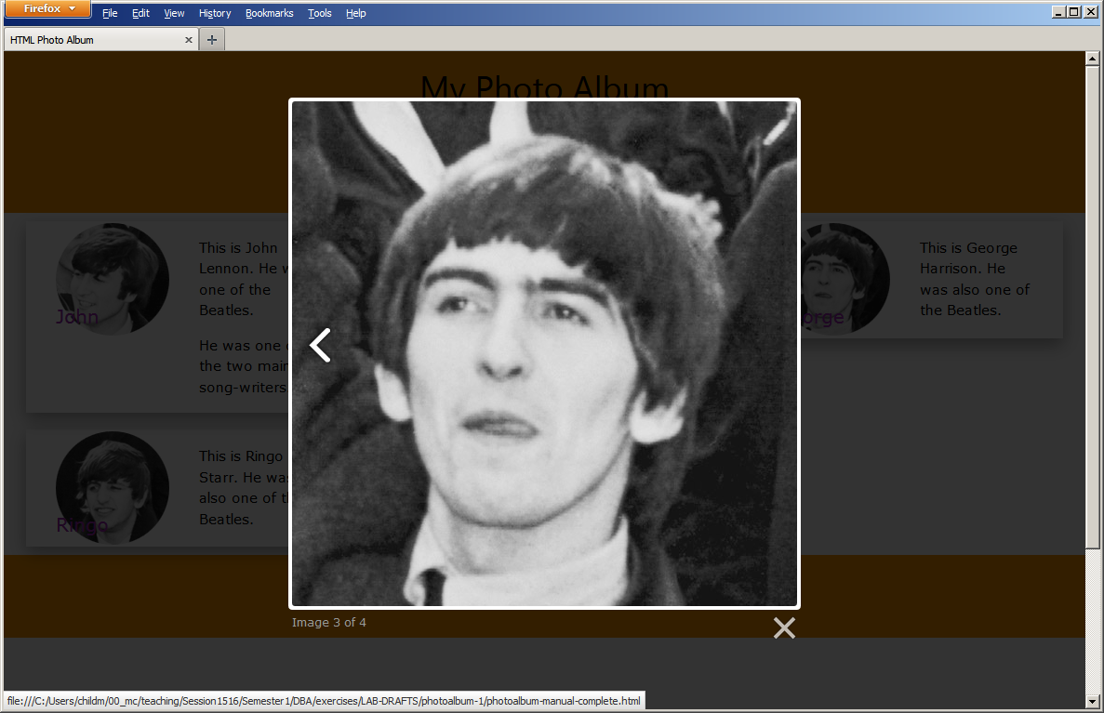

Lightbox adjusts itself to cope with different window widths automatically.

|  |
| --- |
| **EXERCISE 5: BASIC PHOTO ALBUM** |
| ***Required in your report (basic exercise).*** |
| * Give the HTML code for the pictures you added. * A clickable link to the completed web page in your Daydream account. * Write an explanation of how the w3css classes achieve the changing layout of the photographs *and* descriptions, and the cards they are on, as the window width changes, in your report. * Give a critical appraisal of lightbox – do you think it could be better than it is? * Reflection on the tasks and all activities involved. |
| ***Extended Tasks*** |
| * Add lightbox to one of the earlier pages, like the beverages page. * Visit the homepage of the lightbox developers at <http://lokeshdhakar.com/projects/lightbox2> and experiment with modifying the options it provides. * Investigate jQuery and how it can be used. |
| *Additional work: investigate and experiment with any related subject matter that interests you.* |